caBIG-IMG-99-01-31052006
eXtentsible Imaging Platform Development Project /Task 2.8
XIP Release 1.0
Test Results Report

The XIP libraries are tested in a continuous/nightly build/test process using the CMake/CTest system coupled with Cruise Control, with the results posted on a web-based dashboard. The following screen shots show the appearance of the dashboard:

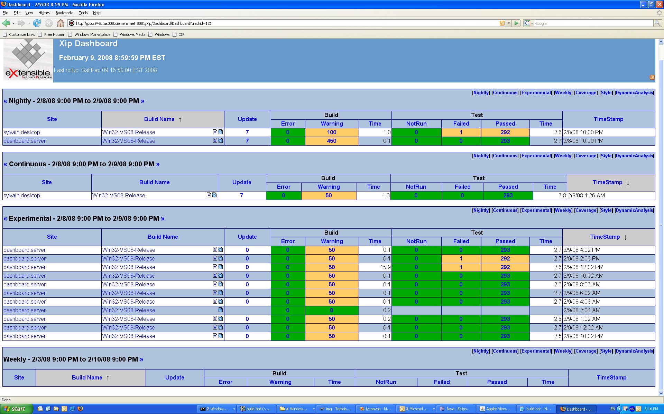
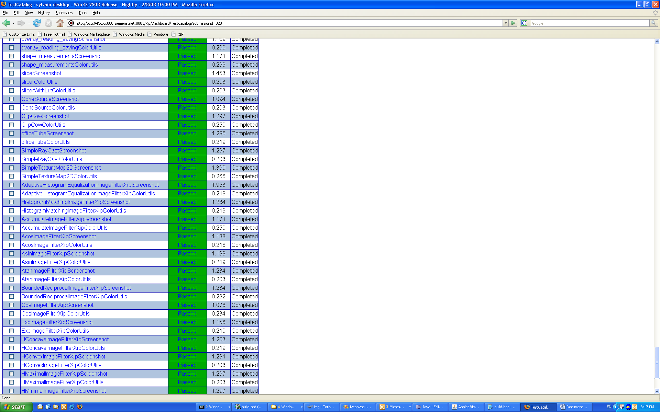

The document XipDashboard.pdf includes a simple dump of the current dashboard results. Also included in this directory is a zip file of the XML test result reports from the automated tests that went into the building of the dashboard. Normally one would access these reports by clicking entries in the web-based dashboard. The warnings reported from the build process have been reviewed by the development team, and are deemed inconsequential for this release. Most come from include files from external libraries.

The results from the testing of the XIP Host implementation and the associated WG-23 Interface class libraries are recorded in the Microsoft Excel spreadsheet XIPHost_Test_2008-01-28.xls.

All currently available tests for XIP Release 1.0, version 25-January-2008 have been completed successfully. Exceptions noted have been discussed with project management and primarily deal with functionality that could not be fully completed due to the late arrival of dependent libraries.

Reported by Lawrence Tarbox, Ph.D.

